CS 255 System Design Document

UML Use Case Diagram
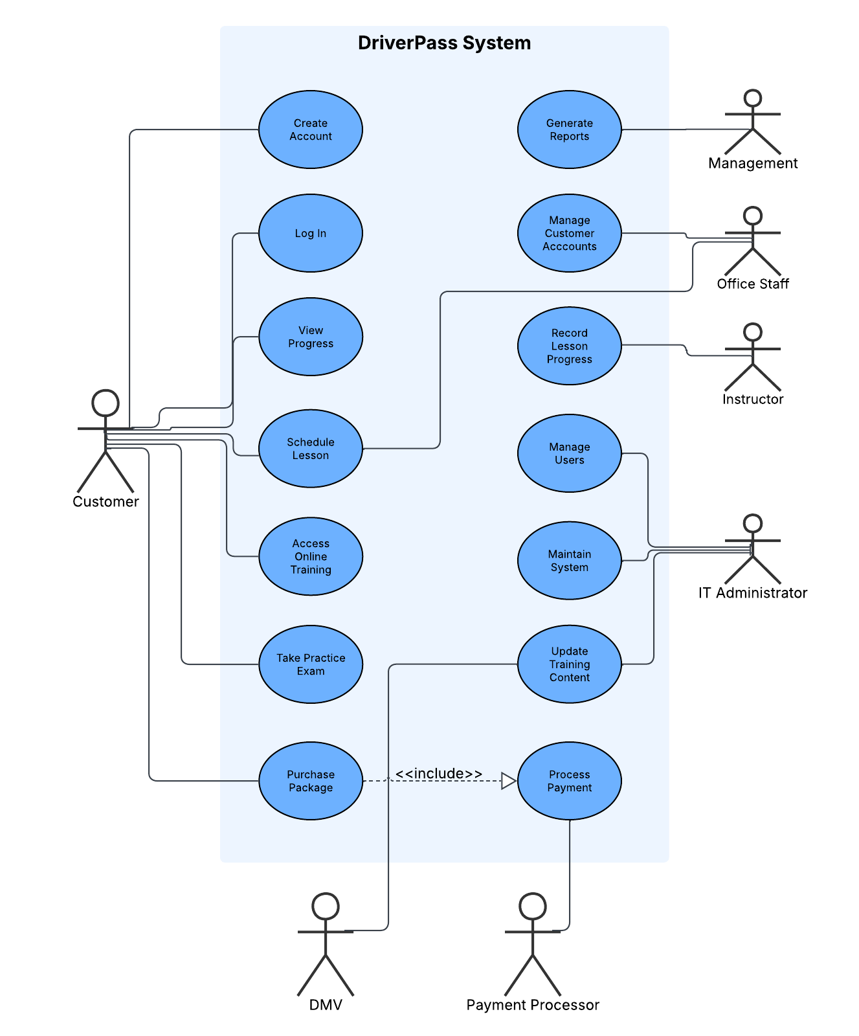

Activity Diagram 1: Purchase Training Package
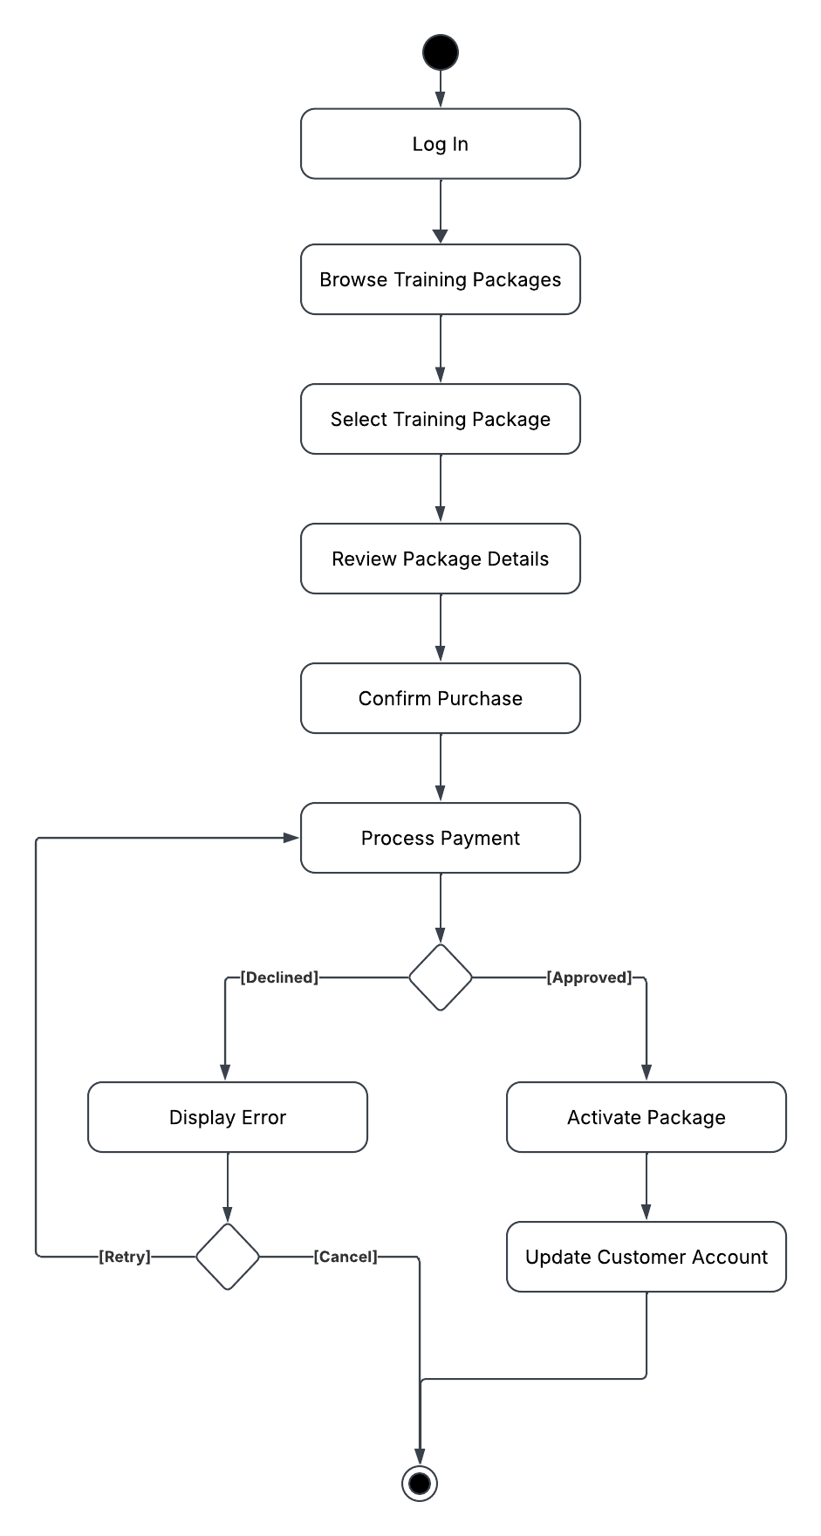

Activity Diagram 2: Schedule Driving Lesson
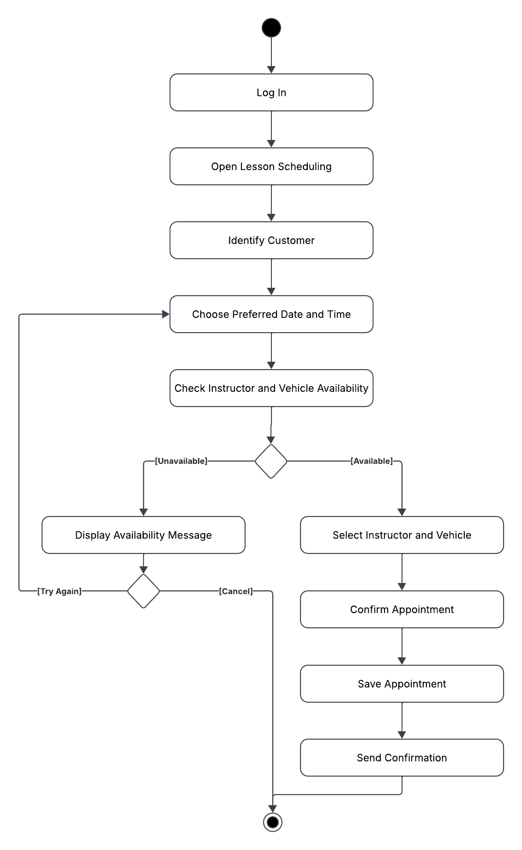

UML Sequence Diagram – Purchase Training Package

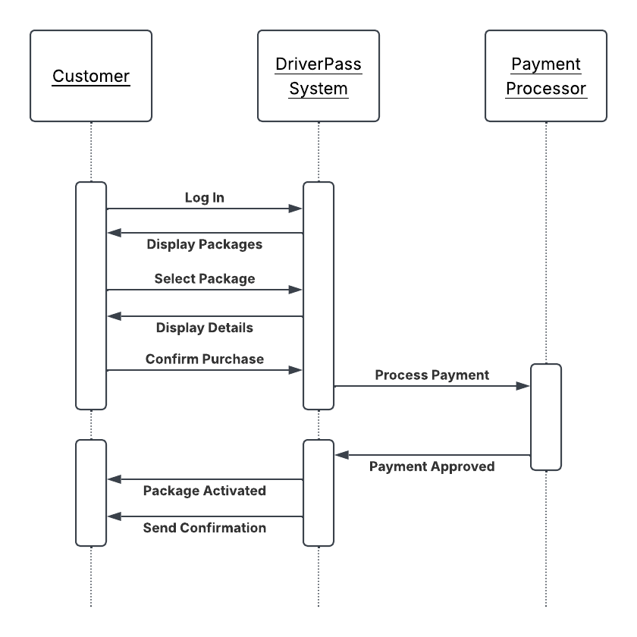

UML Class Diagram

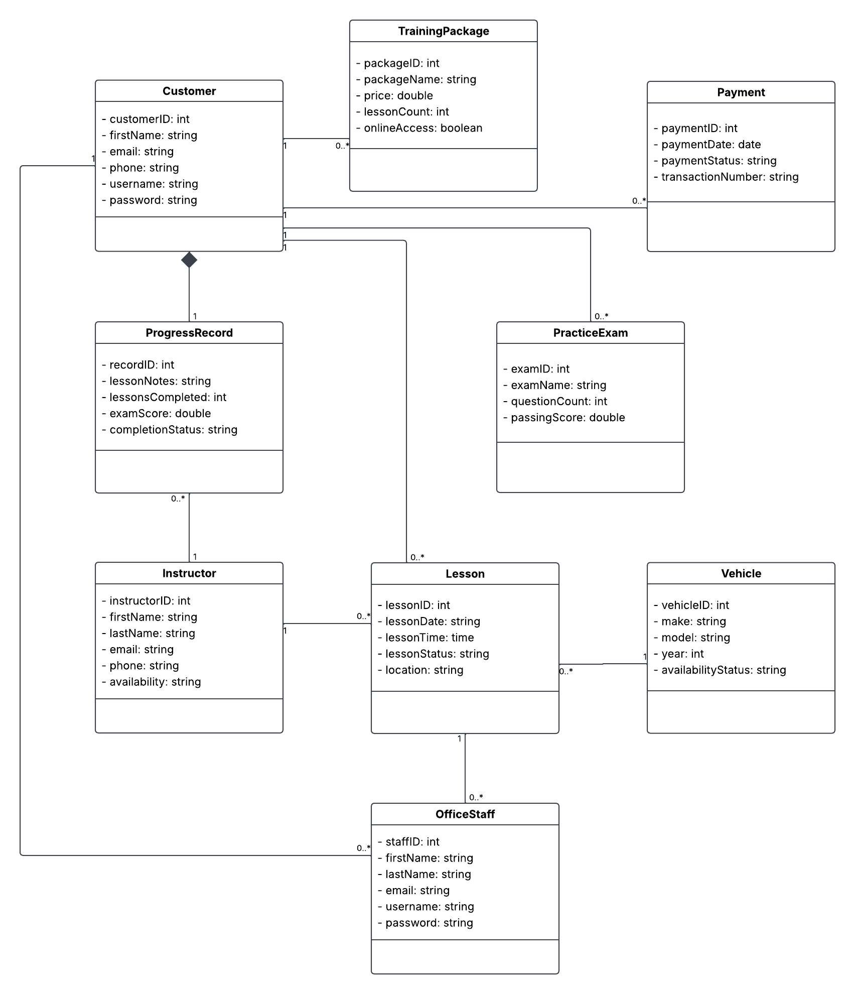

Technical Requirements
The DriverPass system requires reliable hardware, software, and supporting infrastructure to provide customers with online driver education, practice exams, lesson scheduling, and secure payment processing. The system is designed as a web-based application that allows customers, instructors, office staff, management, and IT administrators to access the features appropriate to their roles.
From a hardware perspective, the system requires reliable web and database servers to host the application and store customer accounts, lesson schedules, training records, and payment information. Staff members need computers with internet access to manage customers, instructors, and appointments, while customers require a computer, tablet, or smartphone with a modern web browser and internet connection.
The software requirements include the DriverPass web application, a database management system to maintain customer and training information, secure user authentication with role-based access, and integration with a third-party payment processor. The system also requires access to current DMV training materials so educational content and practice exams remain accurate and up to date.
The supporting infrastructure must provide dependable internet connectivity, secure communication between the application and external services, and reliable data storage to ensure customer information, lesson schedules, and payment records remain available. These technical requirements support a secure, dependable, and efficient system that meets DriverPass's business requirements and customer needs.

